**Project 4: RedBox**

Matthew Conflitti

CIS 163

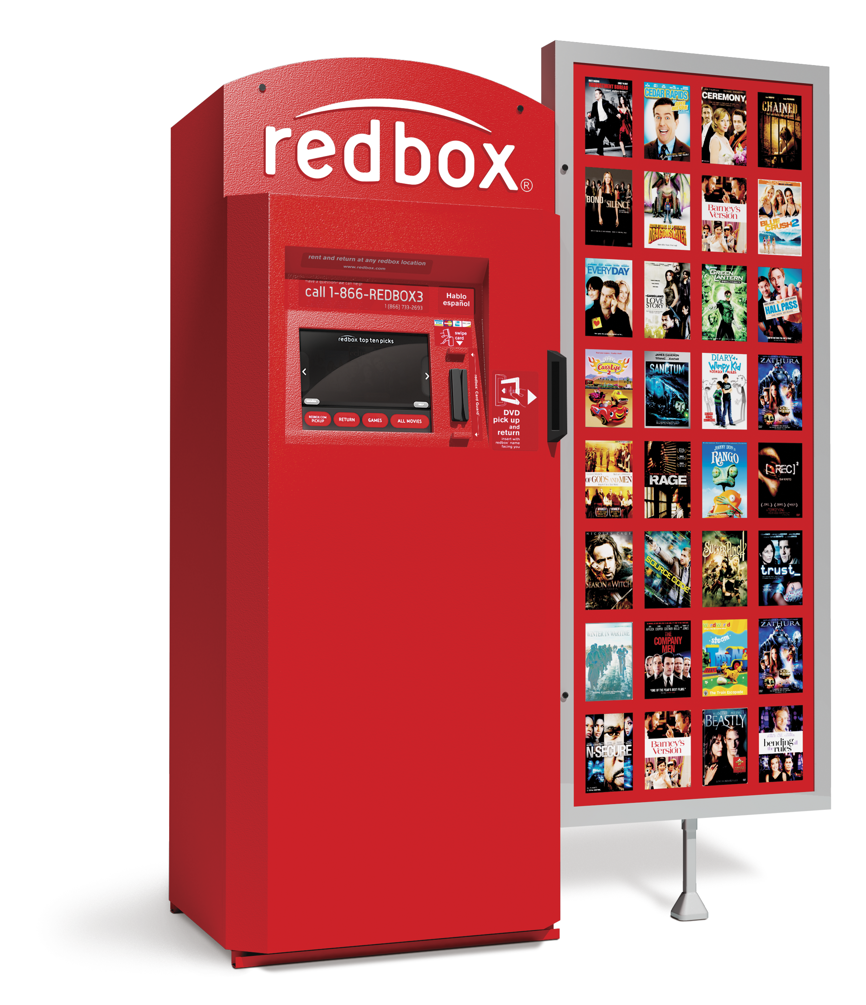

Signed pledge: I pledge that this work is entirely mine, and mine alone (except for any code provided by my instructor).

Time Card: I have spent around 15-20 hours on this project between July 15-29 and reading the book, designing a solution, writing code, fixing errors, and putting together the printed document.

GUI ScreenShot:

